|  |
| --- |
| **DESIGN AND ANALYSIS OF A COMPACT 6-PORT MICROSTRIP MIMO ANTENNA FOR 2.4-GHz WLAN APPLICATIONS** |
| **Nguyen Thi Kim Thu, Nguyen Phuc Ngoc, Nguyen Thi Quynh Hoa**  *School of Engineering and Technology, Vinh University*  Received on 25/01/2019, accepted for publication on 28/3/2019 |

**Abstract:**A compact 6-port MIMO antenna consisting of equilateral triangle elements have demonstrated in order to miniaturize the size and reduce the mutual coupling of antenna elements due to its geometrical shape. The antenna is designed on FR4 material and simulated results by HFSS software are provided. The simulated results show that the proposed MIMO antenna achieves the return loss of less than -10dB and the mutual coupling of less than -12.5 dB between elements in a bandwidth ranging from 2329 to 2495 MHz, which entirely covers WLAN frequency band allocated from 2400MHz to 2480MHz. The obtained results indicate that the proposed antenna is a good candidate for MIMO applications.

**1. Introduction**

Multiple-Input-Multiple-Output (MIMO) technology has been widely applied for wireless communication because it can offer significant increases in data throughput and link range without using additional bandwidth or transmit power [1-9]. By using multiple antennas in both the transmitter and receiver, the MIMO technique can detect multiple independent channels in free space, which can achieve a higher capacity of a link compared to the classic single-antenna design. Due to this unique feature, MIMO has been adopted in all major wireless standards such as IEEE 802.11n (Wi-Fi), 4G, 3GPP Long Term Evolution, WiMAX and HSPA+ [2].

However, a multi-antenna system has just the best performance when the mutual coupling among the antenna elements is low because a strong coupling can lead to not only high correlation but also a severe loss in efficiency of multi-antenna systems. The low mutual coupling can also be obtained by utilizing large spatial separation among antennas, which has an effect on the size of the overall antenna system. Thus, the design of MIMO antenna is still a very challenging task for obtaining both low mutual coupling and compact size because these features remain controversial [1-8].

Many approaches have been reported to reduce the mutual coupling of antenna elements such as the usage of modified ground [3], neutralization-line [4], orthogonal polarizations [2], [5], [6], parasitic coupling elements techniques [7] and the utilization of metamaterials [8]. However, these structures are wavelength-related, which makes them difficult to apply in an ultra-compact MIMO antenna design [1].

Recently, microstrip antenna was used to design compact MIMO antenna [10-12] due to their benefit features such as low profile, low cost, planar configuration, and suitable for an array with the ease of fabrication and integration with microwave monolithic integrated circuits (MMICs). However, most of these studies have been focused on microstrip MIMO antennas with rectangular and E-sharp patches, but very few investigations of microstrip MIMO antenna with triangular patch have been reported so far. Even though, compared to antennas with other patch geometries, the triangular microstrip antenna has advantages such as smaller physical size and lower radiation loss [13]. Furthermore, a triangular patch has a great capability of miniaturization of MIMO antenna due to its geometrical shape.

In this letter, a compact six-port microstrip MIMO antenna using equivalent triangular patches designed for the 2.4 GHz WLAN band is proposed, simulated and evaluated. In this configuration, both low mutual coupling characteristics and miniaturization are realized.

**2. Antenna Design**

Design parameters of the proposed MIMO antenna are shown in Fig. 1. The dimension of the overall antenna structure is 70 mm x 70 mm fabricated on a FR-4 substrate with a dielectric constant of 4.4, a substrate thickness of 1.6 mm, and a loss tangent of 0.02. The top and bottom patches printed on the substrate are the radiating structure and the ground plane. We noted that the area per element of the proposed MIMO of 0.16λ2 is much smaller than that of other microstrip MIMO antenna such as [2], [3], [5].

In the top layer, six equilateral triangle patches are rotationally symmetric with an interval of 600. The dimensions of the equilateral triangle patch of 38.45 mm, designed to operate at 2.4 GHz, the standard frequency for wireless LAN (WLAN), is calculated using the formulas given in [14]. The separation between antennas is optimized at 2.5 mm. Six feeding ports are fed by coaxial cable. The feeding positions are located at the median of the triangle as shown in Fig. 1a; these provide 50Ω interfaces and achieve the impedance matching at the desired frequency. The bottom layer of the substrate is just a ground plane. The proposed MIMO antenna has been simulated by HFFS software.



**Fig. 1:***Schematic of proposed six-port MIMO antenna:*

*(a) Top view and (b) Bottom view*

**3. Results and Discussion**

***3.1. Scattering Parameters***

HFSS software was used to design, simulate and analyze the proposed MIMO antenna. The simulated S-parameters were shown in Fig. 2. Since the radiating elements are rotationally symmetric, only return loss in port one (S11) and the mutual coupling between ports 1 and 2, 3, 4 (S12, S13, S14) are provided.

The proposed MIMO antenna exhibits the return loss (S11) of less than -10dB and the mutual coupling (S12) of less than -12.5 dB in a bandwidth ranging from 2329 to 2495 MHz, which entirely covers WLAN frequency band allocated from 2400MHz to 2480MHz [11]. The isolation is better than -12.5 dB in the whole matching band, indicating that the proposed antenna is suitable for MIMO application [15]. We noted that the obtained bandwidth of the proposed MIMO of 176 MHz is much larger than the bandwidth of others MIMO antenna such as [1], [2].

***3.2. Voltage Standing Wave Ratio***

Voltage Standing Wave Ratio (VSWR) of the proposed MIMO antenna was shown in Fig. 3. Due to the radiating elements are rotationally symmetric, the VSWR in all ports have similar results (data not shown here). The only VSWR in port one is provided. The proposed MIMO antenna have the VSWR value of 1.03 for the 2.4 GHz band frequency which value is less than 2 indicating improved matching conditions [2].

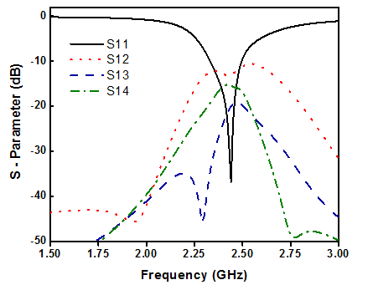

**Fig. 2:***SimulatedS-parameters of the proposed MIMO antenna*

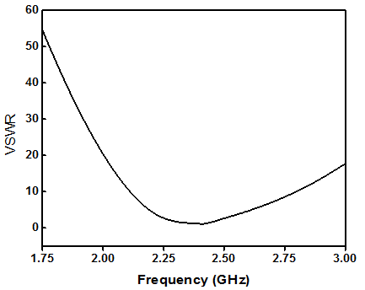

**Fig. 3:***VSWR of the proposed MIMO antenna*

***3.3. Smith Chart***

The scattering parameter S11 for the proposed MIMO antenna at the range of frequencies 1.75 GHz - 3 GHz on the Smith chart is shown in Fig. 4. Because the radiating elements are rotationally symmetric, the similar Smith charts of other ports are observed. As shown in Fig. 4, the proposed antenna exhibits a good impedance matching of approximately 50 Ohms at the resonate frequency.



**Fig. 4:***Smithchart of the proposed MIMO antenna*



(b)

(c)

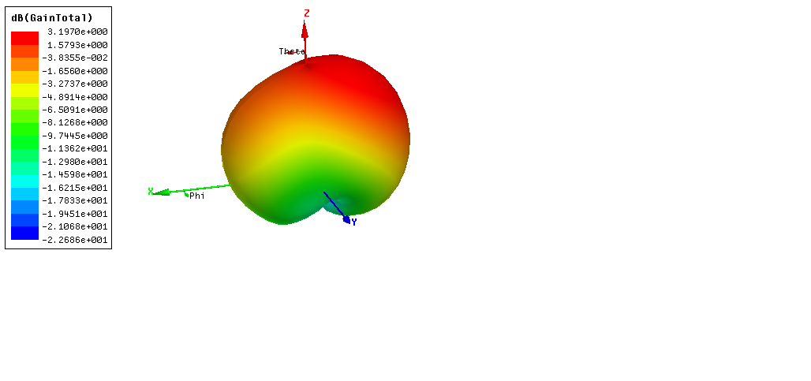

(a)

**Fig. 5: (***a) Gain of the proposed MIMO antenna, (b) Radiation pattern in XOZ plane, and (c) YOZ when feeding port 1*

***3.4. Radiation Patterns and Gain***

Radiation patterns and gain of the proposed antenna were shown in Fig.5. As shown in Fig. 5a, the proposed antenna provides a total maximum gain of 3.19 dB. The directional patterns of port 1 in XOZ and YOZ-plane are provided in Fig. 5 b,c. The 3-dB beamwidth in the XOZ-plane covers 118o, which can not only provide good pattern diversity to boost the channel capacity but also catch the signal from every angle.

***3.5. MIMO performance***

For the antenna used for MIMO application, the correlation coefficient between elements is an important parameter in evaluating performance. The correlation of a two-port can be obtained using the two-port S parameter representation as [16].

 (1)

The correlation coefficient between port 1 and 2 is shown in Fig. 6. The obtained correlation coefficient is lower than 0.03 dB in the whole matching band, which value is sufficient to fulfill the diversity performance for the MIMO antenna [16].

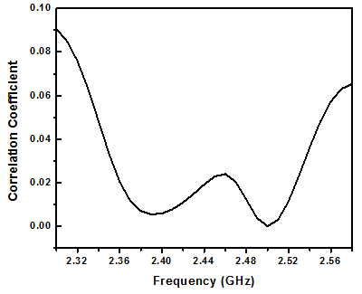

**Fig. 6:***The correlation coefficient of the proposed MIMO antenna.*

**4. Conclusions**

A compact 6-port MIMO antenna consisting of equilateral triangle elements has demonstrated in order to miniaturize the size and reduce the mutual coupling due to its geometrical shape for WLAN applications. The proposed MIMO antenna is simulated and evaluated using HFSS software. The simulated results show that the proposed antenna achieves the resonate frequency at 2.4 GHz, the impedance of 50 Ω, the bandwidth of 176 MHz, the total gain of 3.19 dB and low mutual coupling of less than -12.5 dB through the whole WLAN band. The obtained results prove that the antenna is suitable for MIMO application.

**REFERENCES**

[1] Han Wang, H., Liu, L., Zhang, Z., Li, Y. and Feng, Z., “Ultra-Compact Three-Port MIMO Antenna with High Isolation and Directional Radiation Patterns”,*IEEE Antennas Wireless Propa. Lett.,* 13, pp. 1545-1548, 2014.

[2] Nigam, H., Kumar, M. , “Design and Analysis of 2x2 MIMO System for 2.4 GHz ISM Band Applications”,*International Journal of Advanced Research in Computer Engineering & Technology,* 3, pp. 1794-1798, 2014.

[3] OuYang, J., Yang, F., and Wang, Z. M.,“Reducing mutual coupling of closely spaced microstrip MIMO antennas for WLAN application”,*IEEE Antennas Wireless Propag. Lett., 1*0, pp. 310 - 313, 2011.

[4] Su, S.-W., Lee, C.-T. and Chang, F.-S., “Printed MIMO-antenna system using neutralization-line technique for wireless USB-dongle applications”,*IEEE Antennas Wireless Propag. Lett.,* 60*,* pp. 456-463, 2012.

[5] Babu, K. J, Krishna, K. S., and Reddy, L. P.,“A multi slot patch antenna for 4G MIMO communications”,*International Journal of Future Generation Communication and Networking,* 4, pp. 105-112, 2011.

[6] Gao C, Li X-Q, Lu W-J, Wong K-L. Conceptual design and implementation of a four-element MIMO antenna system packaged within a metallic handset (2018). *Microw Opt Technol Lett*; 8, pp. 436-444, 2018.

[7] Li et al.,“Reducing mutual coupling of MIMO antennas with parasitic elements for mobile terminals”,*IEEE Trans. Antennas Propag.,* 60,pp. 473-481, 2012.

[8] Zhai, G., Chen, Z. N. Qing, X., “Enhanced Isolation of a Closely Spaced Four-Element MIMO Antenna System Using Metamaterial Mushroom”,*IEEE Trans. Antennas Propag.,* 63, pp. 3362- 3370, 2015.

[9]. Nasir, J., Jamaluddin, M. H., Khalily, M., Kamarudin, M. R., Ullah, I. (2016). Design of a MIMO Dielectric Resonator Antenna for 4G Applications. *Wireless. Pers. Commun.*.doi. 10.1007/s11277-016-3174-3.

[10] R. Pavithra, R., Mohanageetha, D., Mary Anita, E. A., Subramaniam, M. (2014). A New Compact Microstrip Integrated E-Array Patch Antenna with High Gain and High Aperture Efficiency. *Wireless. Pers. Commun., 78,* 1011-1020.

[11] Afrough, M., Fakharian, M. M., Tavakol-Hamedani, F. (2015). Compact Dual-Band Suspended Microstrip Slot Antenna with an Antipodal Parasitic Element for WLAN Applications. *Wireless. Pers. Commun., 83*, 571-579.

[12] Hamed, H., and Ghouz, M. (2015). Novel Compact and Dual-Broadband Microstrip MIMO Antennas for Wireless Applications. *Progress InElectromagnetics Research B, 63,* 107-121.

[13]. Hassani, H.R., Mirshekar-Syahkal, D., (1992). Analysis of Triangular Patch Antennas Including Randome Effects. *IEEE Proc. H Microwave and Prop., 139*, 251-256.

[14] Bahl, I. J., Bharta, P. (1980). Microstrip Antenna. Artech House, Massachusetts, USA.

[15] Muhammad Sajjad Ahmad, Wahab Mohyuddin, Hyun Chul Choi, and Kang Wook Kim (2018). 4x4 MIMO antenna design with folded ground plane for 2.4 Ghz WLAN applications. *Microw Opt Technol Lett, 5,*395-399.

[16] Ren, J., Hu, W. (2014). Compact Print MIMO Antenna for UWB Applications. *IEEE Antennas Wireless Propa. Lett., 13*, 1517-1520.

**Tóm tắt**

**PHÂN TÍCH VÀ THIẾT KẾ ANTEN MIMO 6 CỔNG KÍCH THƯỚC NHỎ CHO ỨNG DỤNG WLAN**

Anten MIMO 6 cổng kích thước nhỏ gọn được thiết kế bằng cách ghép các thành phần có dạng hình tam giác đều được trình bày nhằm mục đích tối thiểu hóa kích thước và giảm độ tương hỗ giữa các thành phần anten do cấu trúc hình học của nó. Anten được thiết kế trên nền vật liệu FR4 và mô phỏng bằng phần mềm HFSS. Các kết quả mô phỏng cho thấy anten được đề xuất có độ suy hao thấp hơn -10dB và độ tương hỗ giữa các thành phần thấp hơn -12.5dB trong dải băng tần từ 2329 tới 2945 MHz, hoàn toàn bao phủ băng tần WLAN từ 2400 tới 2480 MHz. Các kết quả thu được chỉ ra rằng anten được đề xuất phù hợp cho các ứng dụng MIMO.