Vocational training for Vietnamese rural workers – Case study of Nghe An Province

Authors
- Associate Professor Dr. Dinh Trung Thanh
- Master Hoang Viet Dung
- Dr. Nguyen Thi My Huong
- Master Nguyen Thi Diep
- Dr. Nguyen Thi Hai Yen

DOI:
https://doi.org/10.59670/ml.v20i7.4690

ABSTRACT
Vocational training for rural workers is an important task that contributes to improving labor quality, creating job opportunities, and increasing income. At the same time, it contributes to changing the position of rural workers in our country because rural workers are not highly appreciated for their socio-political status, because production is mainly based on outdated methods. Fragmented, they do not represent advanced production methods. During the vocational training process, workers are equipped with knowledge about production of professions, knowledge about science - technology, market, integration... These are important knowledge to help farmers. Gradually improve production methods in an advanced and modern direction; thereby changing its socio-political position.
Vocational training for rural workers in Nghe An province has achieved relatively comprehensive results in recent times. From the practical results of vocational training for rural workers in the province in recent times, it shows that vocational training for rural workers in Nghe An province still has many problems that need to be resolved and resolved. Therefore, the article aims to build a theoretical framework for vocational training for rural workers and recommend solutions for the Nghe An provincial government in vocational training for rural workers in the province during the period. next.
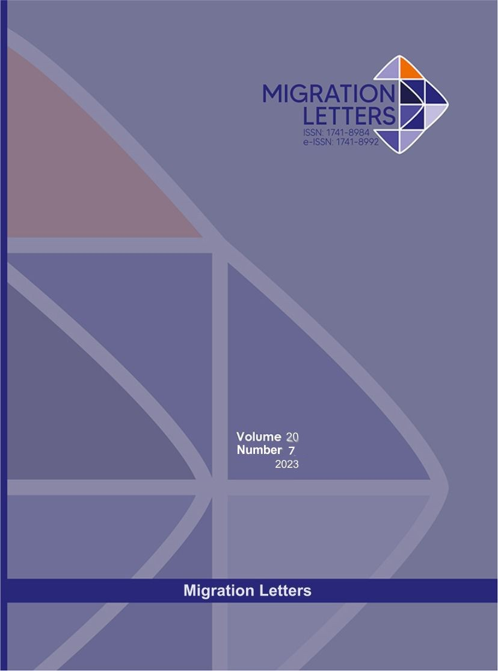

Downloads
- PDF

PUBLISHED
2023-10-13

HOW TO CITE
Associate Professor Dr. Dinh Trung Thanh, Master Hoang Viet Dung, Dr. Nguyen Thi My Huong, Master Nguyen Thi Diep, & Dr. Nguyen Thi Hai Yen. (2023). Vocational training for Vietnamese rural workers – Case study of Nghe An Province . Migration Letters, 20(7), 1008–1026. https://doi.org/10.59670/ml.v20i7.4690
More Citation Formats

ISSUE
Vol. 20 No. 7 (2023)

SECTION

