COMPARISON OF EFFECTIVE MODE AREA AND NONLINEAR COEFFICIENT CHARACTERISTICS OF CIRCULAR AND RECTANGULAR PHOTONIC CRYSTAL FIBER WITH HOLLOW-CORE INFILTRATED CARBON DISULFIDE
Oanh Truong Thi Chuyenª, Ngoc Vo Thi Minh^{b}, Thanh Thai Doan^{c}, Trang Do Mai^{b}, Hoang Trinh Ngoc^{b}, Mai Nguyen Thi Quynh^{d}, Thuy Hoang Van^{b}, Lanh Chu Van^{b*}

^{a)} Nguyen Quang Dieu High School for the Gifted, Cao Lanh, Vietnam
^{b)} Vinh University, 182 Le Duan, Vinh City, Viet Nam
^{c)} Ho Chi Minh City University of Food Industry, 140 Le Trong Tan, Tan Phu, HCM City, Viet Nam
^{d)} Tan An High School, Long An, Vietnam
E-mail: chuvanlanh@vinhuni.edu.vn
Abstract: In this paper, we simulate and compared the effective mode area and the nonlinear coefficient of circular and rectangular lattices photonic crystal fibers (PCFs) structures when infiltrating carbon disulfide (CS₂). By changing the lattice constant Ʌ = 1.0 µm; 1.5 µm; 1.8 µm, and 2.0 µm with the filling factor d₁ /Ʌ from 0.3 to 0.8 to change the core diameter D_{c} (D_{c} = 2Ʌ - 1.2d₁, there d₁ is the first ring diameter), we have selected 02 structures of the circular lattice of fibers #CF₁ (Ʌ = 1.0 µm, d₁ /Ʌ = 0.75, D_{c} = 1.1 µm), #CF₂ (Ʌ = 1.0 µm, d₁ /Ʌ = 0.8, D_{c} = 1.04 µm) and 02 structures of the rectangular lattice of fibers # F₁ (Ʌ = 1.0 µm, d₁ /Ʌ = 0.75, D_{c} = 1.1 µm), and #RF₂ ( Ʌ = 1.0 µm, d₁ /Ʌ = 0.8, D_{c} = 1.04 µm). When comparing the effective mode area and nonlinear coefficient of these optimal structures, we found that at the same structural parameters with the same pump wavelength of 1.55 µm, the #CF₁ has an effective mode area smaller by 0.137 µm² and the nonlinear coefficient is higher by 5170 W ⁻¹.km ⁻¹ than the # RF₁; these results correspond to 0.138 µm² and 2820 W ⁻¹ .km ⁻¹ when comparing two fibers #CF₂ and #RF₂. From this, we show that when CS₂ is infiltrated into the core, we have found the optimal PCF fibers with a small effective mode area and high nonlinear coefficient there the circular lattices are more optimal than the rectangular lattices. The structures we propose are very suitable for the study of supercontinuum generation (SC) in the near-infrared region.
I. Introduction
Photonic crystal fiber (PCF) is very popular in the optical field due to its versatility and applications. PCF can be characterized by changing its structural parameters. However, once the specific design of the PCF has been fabricated, it becomes difficult to change its optical properties. To overcome this problem, since 2006, people have been injecting liquid into the fiber core to control the characteristics of PCF [1] and therefore, the applications of PCF have also been further enhanced such as optical amplifiers, chemical and biochemical sensors [2-3], fiber lasers [4] and especially supercontinuum(SC) [5].
As is known, for a PCF fiber to have good SC efficiency, one of the main determining factors is that its core must have a high nonlinear coefficient with a small effective mode area (A_{eff} ). The effective mode area is a very important quantity and is considered a measure of the nonlinearity of the PCF fiber. When the effective mode area is low for high power density, which is essential for nonlinear effects. Besides, the effective mode area has a great influence on the loss inside the PCF fiber such as confinement loss [6]… Therefore, it is necessary to choose a liquid with a high nonlinear refractive index to inject into the PCF fiber core and found the optimal structure with a small effective mode area for application in SC.
To do this, we have carried out an infiltration of Carbon disulfide (CS₂) into the PCF fiber core. In this paper, we choose circular and rectangular lattices PCF with the same silica substrate, inside the fiber, there are 8 circularly arranged stomatal rings with lattice constant values Ʌ = 1.0 µm; 1.5 µm; 1.8 µm, and 2.0 µm; where the diameter of the first ring is variable (D_{c} = 2Ʌ - 1.2d₁) by changing the fill factor of the first ring d₁ / Ʌ from 0.3 to 0.8. With the help of Lumarical Mode Solutions (LMS) and Matlab, we have simulated numerically and produced the characteristic line shape the effective mode area and the nonlinear coefficient of two structures. By doing this, we can completely compare the effective mode area and nonlinearity coefficient of circular and rectangular lattices PCF structures, thereby finding the optimal structure for application and SC.
II. Describe the structure and theory of effective mode area, nonlinear coefficients in crystalline optical fibers
The structure of PCF circular and rectangular lattices is simulated as shown in Figure 1.
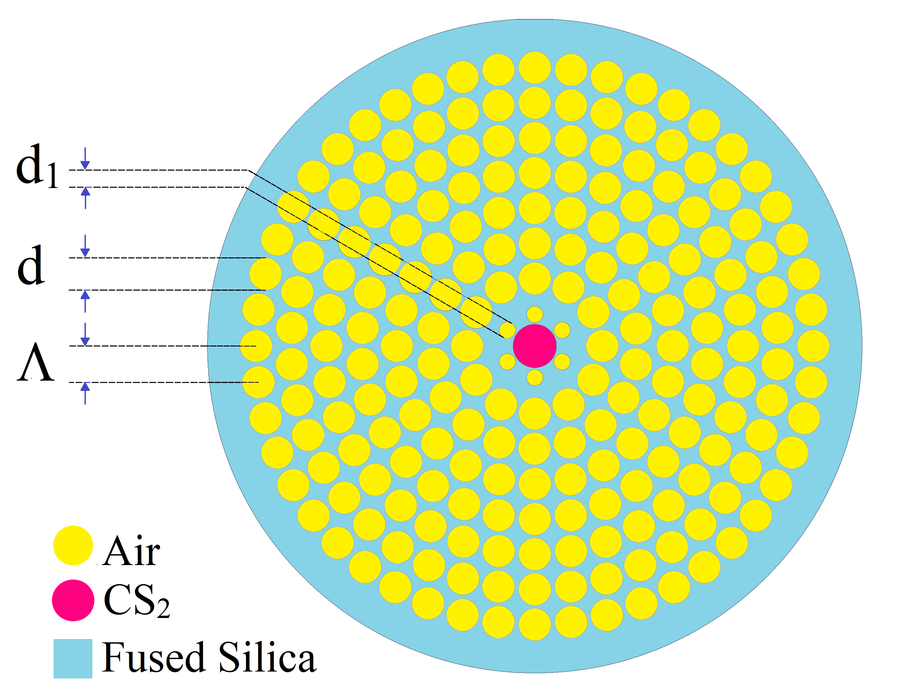 | 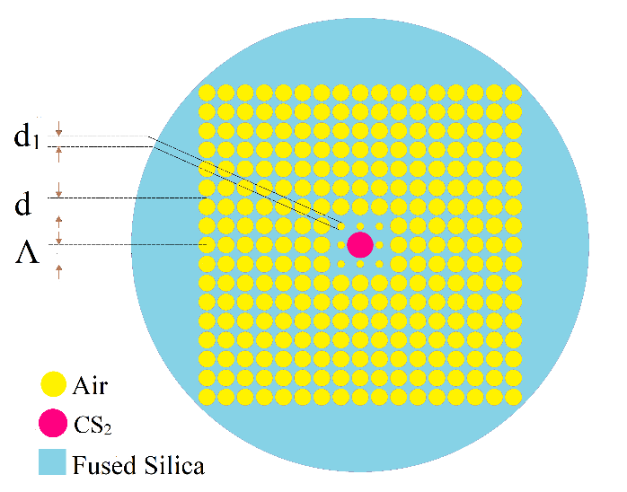
(a) | (b)
Figure 1. Diagram of modeling the geometrical structure of PCF circular lattice (a), and rectangular lattice (b)
From Figure 1, the two structures that we used for simulation have 8 stomatal rings with lattice constants with values Ʌ = 1.0 µm; 1.5 µm; 1.8 µm, and 2.0 µm where the first ring diameter d₁ can be changed by varying the fill factor d₁/Ʌ from 0.3 to 0.8; the central core permeable by CS₂ has a diameter between 0.52 µm and 1.64 µm (D_{c} = 2Ʌ - 1.2d₁ ).
CS₂ is chosen because the nonlinear coefficient extremely is large and much higher than Carbon tetrachloride (CCl₄) or Chloroform (CHCl₃). The nonlinear refractive index of CS₂ has a value of 320.10⁻²⁰ m²/W at 1.55 µm and is 100-fold higher than that of silica (SiO₂) [7] and thus, SC in the infrared and infrared regions can be induced in hollow-core PCF fibers filled with CS₂ [8-10]. The difference in the nonlinear refractive index of CS₂ compared with CCl₄ and CHCl₃ is depicted in Figure 2.
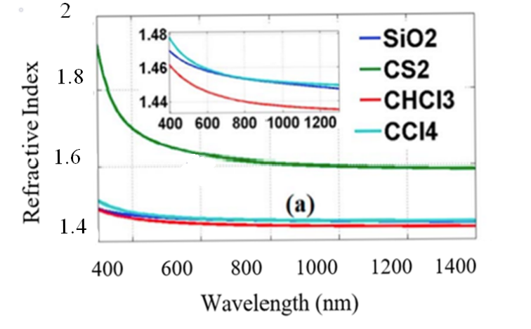
Figure 2. The refractive index curves of CS₂ versus CCl₄ and CHCl₃ [7]
As mentioned, the nonlinear coefficient of the PCF fiber plays a very important role for SC. The larger the PCF nonlinear coefficient, the higher the super continuous transmission efficiency. The nonlinear coefficient is given by the formula [11]
(1)
where A_{eff} is the effective mode area given by [11]
(2)
Thus, choosing CS₂ with a large nonlinear refractive index to penetrate the PCF core and choosing a structure with a small effective mode area will be favorable conditions for SC research.
In this paper, we compare effective mode area and the nonlinear coefficient of two hollow core PCF structures with circular and rectangular lattices permeated CS₂ with silica substrates. The object that we aim to conduct the comparison is PCF structures with small the effective mode area and high the nonlinear coefficient.
III. Results and Discussion
To compare the effective mode area and the nonlinear coefficient of two hollow core PCF structures permeable CS₂, we simulate using LMS software the PCF structures with lattice constant Ʌ = 1.0 µm; 1.5 µm; 1.8 µm and 2.0 µm have a first ring diameter that can be changed by varying the fill factor d₁/Ʌ from 0.3 to 0.8 and get the results shown in Figure 3.
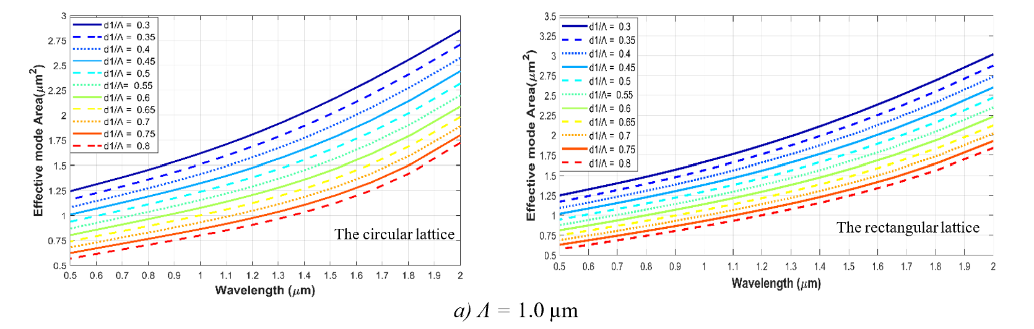
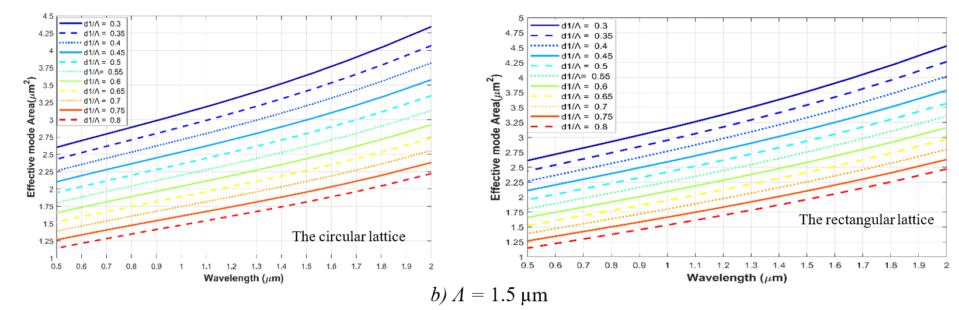
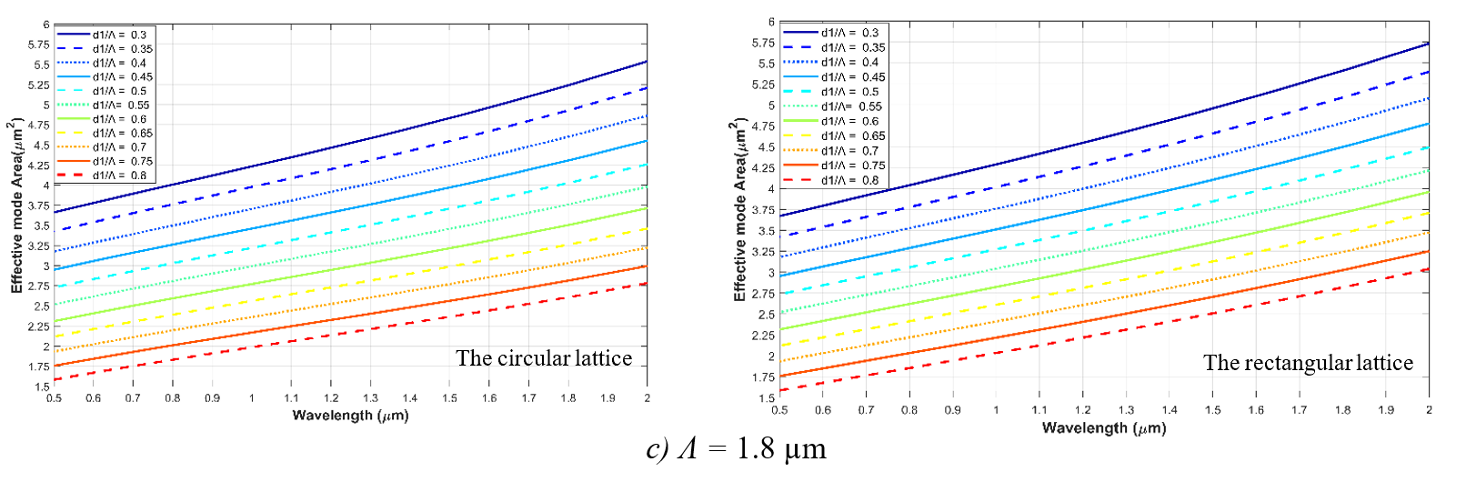
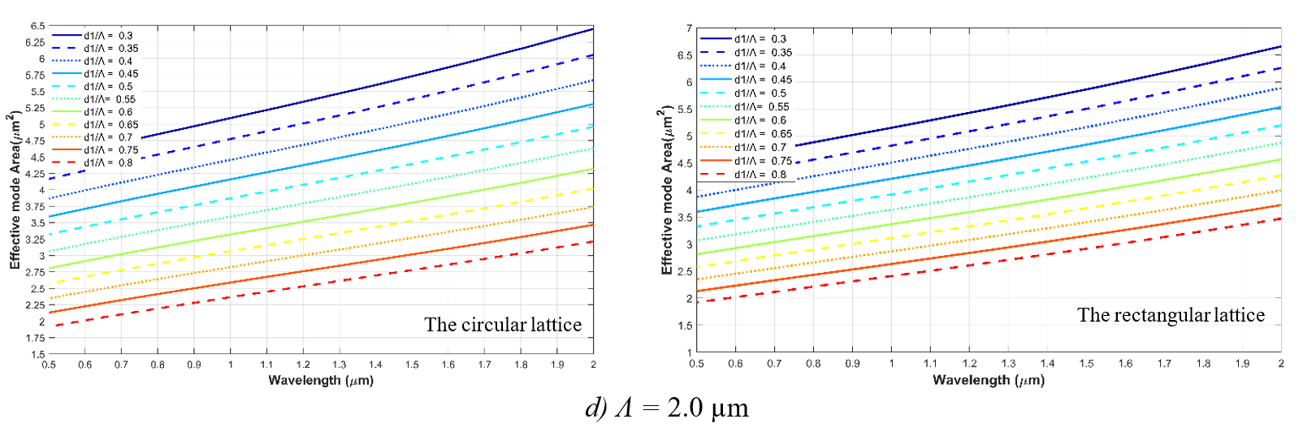
Figure 3. Effective mode area graph A_{eff} of PCF circular and rectangular lattices infiltrated CS₂ a) Ʌ = 1.0 µm ; b) Ʌ = 1.5 µm ; c) Ʌ = 1.8 µm ; d) Ʌ = 2.0 µm .
In general, for two PCF structures circular and rectangular lattices, when at the same lattice constant, the effective mode area will increase as the wavelength increases and decrease as the fill factor increases. To further clarify the value of A_{eff}, we proceed to calculate the value of effective mode area at the pump wavelength of 1.55 µm as Table 1.

Table 1. Table of the effective mode area A_{eff} (µm²) values of circular and rectangular lattices PCF structures permeable to CS₂ at pumping wavelength 1.55 µm.
d₁/Ʌ | Ʌ = 1.0 µm |  | Ʌ = 1.5 µm |  | Ʌ = 1.8 µm |  | Ʌ = 2.0 µm
 | Circle  lattice | Rectangular  lattice | Circle  lattice | Rectangular  lattice | Circle  lattice | Rectangular  lattice | Circle  lattice | Rectangular  lattice
0.3 | 2.115 | 2.313 | 3.704 | 3.834 | 4.897 | 5.03 | 5.795 | 5.936
0.35 | 2.071 | 2.182 | 3.471 | 3.834 | 4.606 | 4.727 | 5.441 | 5.573
0.4 | 1.943 | 2.058 | 3.255 | 3.606 | 4.299 | 4.440 | 5.093 | 5.232
0.45 | 1.821 | 1,941 | 3.047 | 3.189 | 4.023 | 4.167 | 4.763 | 4.905
0.5 | 1.708 | 1.830 | 2.848 | 2.996 | 3.758 | 3.906 | 4.448 | 4.592
0.55 | 1.60 | 1.725 | 2.660 | 2.809 | 3.505 | 3,652 | 4.145 | 4.287
0.6 | 1.498 | 1.628 | 2.480 | 2.634 | 3.262 | 3.415 | 3.853 | 4.001
0.65 | 1.403 | 1.535 | 2.308 | 2.465 | 3.031 | 3.182 | 3.575 | 3.723
0.7 | 1.314 | 1.448 | 2.149 | 2.305 | 2.812 | 2.966 | 3.313 | 3.459
0.75 | 1.23 | 1.367 | 1.993 | 2.152 | 2.602 | 2.756 | 3.059 | 3.207
0.8 | 1.152 | 1.29 | 1.849 | 2.007 | 2.401 | 2.557 | 2.82 | 2.967
From table 1, it can be seen that for circular lattice the minimum effective mode area is 1.152 µm² and the largest is 5.795 µm². Meanwhile, this result for rectangular lattice is 1.29 µm² and 5.936 µm². Thus, at the same parameters, circular lattice PCF structures at 1.55 µm pump wavelength give the effective mode area smaller than rectangular lattices. From this result, we choose the optimal 02 fibers about the effective mode area for each lattice structure as shown in Table 2.
Table 2. Optimal structures of the effective mode area of PCF circular and rectangular lattices
PCF structure | # | A_{eff} (µm² )
Circular lattice | #CF₁ : Ʌ = 1.0 µm, d₁ /Ʌ = 0.75, D_{c} = 1.1 µm | 1.23
 | #CF₂ : Ʌ = 1.0 µm, d₁ /Ʌ = 0.8, D_{c} = 1.04 µm | 1.152
Rectangular lattice | #RF₁ : Ʌ = 1.0 µm, d₁ /Ʌ = 0.75, D_{c} = 1.1 µm | 1.367
 | #RF₂ : Ʌ = 1.0 µm, d₁ /Ʌ = 0.8, D_{c} = 1.04 µm | 1.29

The schematic diagram of the selected optimal structures is depicted in Figure 4:
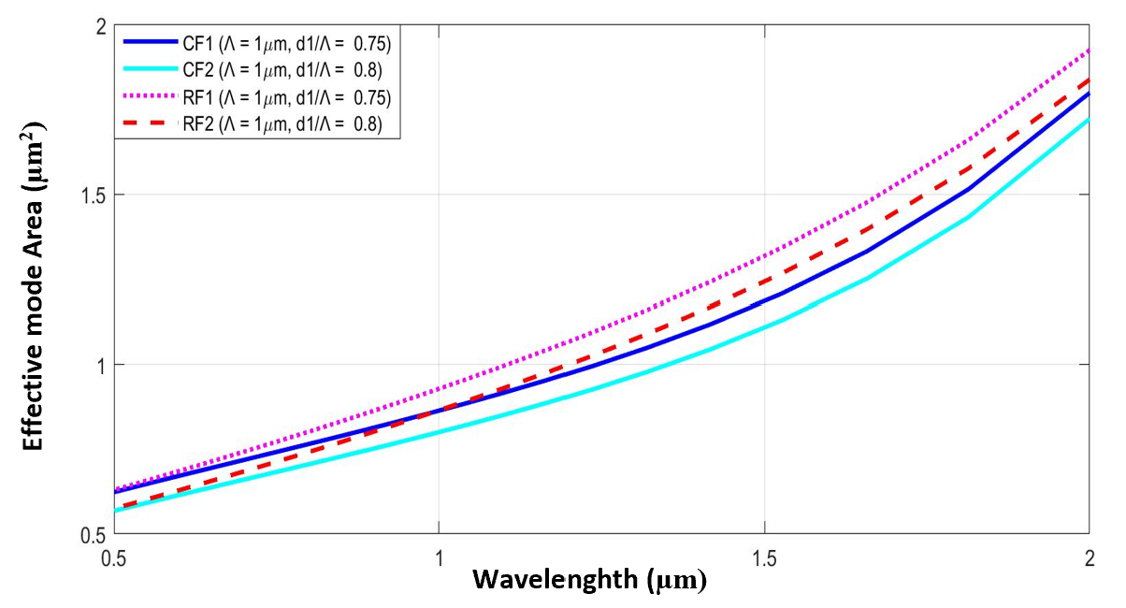
Figure 4. Synthesis of the effective mode area of the PCF structures #CF₁, #CF₂, #RF₁, and #RF₂ of the circular and rectangular lattices when permeating CS₂.
From Table 2 and Figure 4 it can be seen that, as the wavelength increases, the effective mode area of the PCF constructs #CF₁, #CF₂, #RF₁, and #RF₂ also increase, especially rapidly in the wavelength range from 1.5 µm to 2.0 µm. When comparing at the same wavelength of 1.55 µm, at the same parameter Ʌ = 1.0 µm, d₁/Ʌ = 0.75, D_{c} = 1.1 µm, the #CF₁ structure of the circular lattice has the effective mode area 0.137 µm² smaller than #RF₁ fiber of the rectangular lattice; while this difference is in Ʌ = 1.0 µm, d₁/Ʌ = 0.8, D_{c} = 1.04 µm of #CF₂ and #RF₂ is 0.138 µm².
Next, we compare the nonlinear coefficients of #CF₁, #CF₂, #RF₁, and #RF₂ fibers at a pump wavelength of 1.55 µm. The nonlinear coefficients of the optimal structures are depicted as shown in Figure 5.
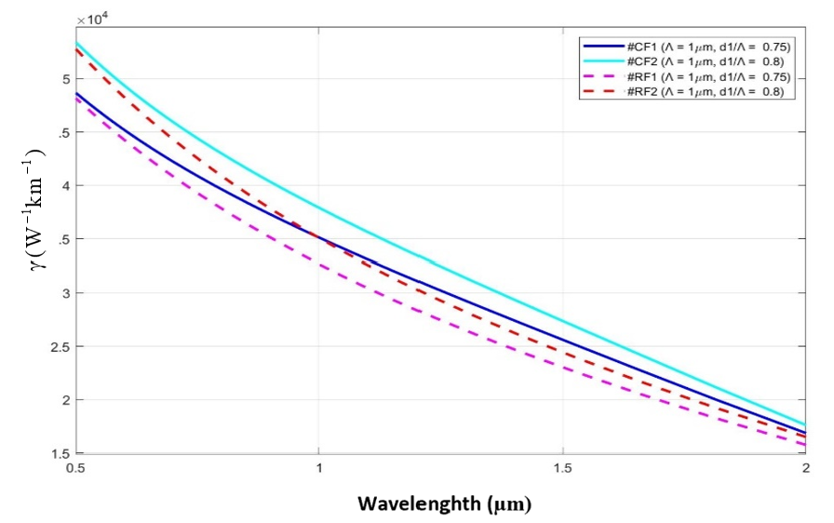
Figure 5. Summary of the PCF structures #CF₁, #CF₂, #RF₁, and #RF₂ of the circular and rectangular lattices when permeating CS₂.
From Figure 5, the nonlinear coefficient of the structures #CF₁, #CF₂, #RF₁, and #RF₂ of the circular and rectangular lattices under CS₂ permeation decrease rapidly with increasing wavelength. When at the same structure parameters, the nonlinear coefficient of #CF₁, and #CF₂ fibers of the circular lattice are both larger than those of the #RF₁ and #RF₂ fibers of the rectangular lattice. At the pump wavelength of 1.55 µm, these structures give values as shown in Table 3:
PCF structure | # | (W ⁻¹.km ⁻¹ )
Circular lattice | #CF₁ | 27400
 | #CF₂ | 26370
Rectangular lattice | #RF₁ | 22230
 | #RF₂ | 23550
Table 3. Values the nonlinear coefficient of the structures #CF₁, #CF₂, #RF₁ and #RF₂ at pump wavelength 1.55 µm.

Table 3 shows the optimal structures about A_{eff} of the circular and rectangular lattices when permeation CS₂ has very high nonlinear coefficients. In which, when at the same structural parameters and the same pump wavelength, it is 1.55 µm then #CF₁ fiber is about 5170 W ⁻¹.km ⁻¹ larger than #RF₁ fiber and #CF₂ fiber is also larger by 2820 W ⁻¹.km ⁻¹ compared to fiber #RF₂. Thus, the circular lattice structure is more optimal than the rectangular lattice because the effective mode area is small and the nonlinear coefficient is high when impregnated with the same liquid as CS₂. This is a very favorable condition for super continuous generation research. The results outlined in this paper are also optimal compared with some previous publications, as shown in Table 4.
Table 4. The characteristic values of the proposed PCFs in comparison with previous publications.
Photonic crystal fibers | Liquids | # | D_{c}  (μm) | Pump wavelength  (µm) | A_{eff}  (µm² ) | (W ⁻¹ .km ⁻¹ )
[12] | CCl₄ | #F₁ | - | 1.55 | 11.83 | -
 |  | #F₂ | - | 1.55 | 10.58 | -
[13] | CHCl₃ | #F₁ | - | 1.03 | 1.5 | 1290
 |  | #F₂ | - | 1.03 | 4.48 | 440
[14] | C₇ H₈ | #I_0.3 | 3.34 | 1.55 | 7.78 | -
 |  | #I_0.35 | 3.23 | 1.55 | 78.9 | -
[15] | CS₂ | - | - | 1.55 | 1.63 | 7940
This work | CS₂ | #CF₁ | 1.1 | 1.55 | 1.23 | 27400
 |  | #CF₂ | 1.04 | 1.55 | 1.152 | 26370
 |  | #RF₁ | 1.1 | 1.55 | 1.367 | 22230
 |  | #RF₂ | 1.04 | 1.55 | 1.29 | 23550

IV. Conclusion

In this paper, with changing lattice constant and fill factor d₁/ Ʌ from 0.3 to 0.8 to change the first ring diameter and core diameter (from 0.52 µm to 1.64 µm), we simulated and obtained structures with the effective mode area optimized with nonlinear coefficient high composed of fibers #CF₁, #CF₂, #RF₁, and #RF₂ of the circular and rectangular lattices when penetrated with CS₂. The results show that the permeation of CS₂ into the PCF core of the circular and square lattices obtained structures with the effective mode area is small (from 1.152 µm² to 5.795 µm² for circular lattice and from 1.29 µm² up to 5.936 µm² for rectangular lattice at pump wavelength 1.55 µm). Furthermore, the effective mode area of circular lattice structures is better than rectangular lattices. Specifically, when at the same structural parameters and the same pumping wavelength of 1.55 µm, the effective mode area of #CF₁ fiber is less than 0.137 µm² and the nonlinear coefficient higher than 5170 W ⁻¹.km ⁻¹ compared to fiber #RF₁; these results correspond to 0.138 µm² and 2820 W ⁻¹ .km ⁻¹ when comparing the two fibers #CF₂ and #RF₂. These are the optimal fibers with the effective mode area small and high nonlinear coefficients that are good candidates for the study of super continuous emission in the near-infrared region.
Acknowledgments
This research is funded by Vietnam National Foundation for Science and Technology Development (NAFOSTED) under grant number 103.03-2020.03.
References
[1]. Hoo YL, Jin W, Shi C, Ho HL, Wang DN, Ruan SC, “Design and modeling of a photonic crystal fiber gas sensor” Vol. 42, Issue 18, 2003, pp. 3509-3515.
[2]. Sayed Asaduzzaman, Md. Faizul Huq Arif, Kawsar Ahmed, and Priyanka Dhar, “Highly Sensitive Simple Structure Circular Photonic Crystal Fibre based Chemical Sensor”, 2015, IEEE (WIECON-ECE) 19-20.
[3]. Ahmmed A. Rifat1, Kawsar Ahmed, Sayed Asaduzzaman, Bikash Kumar Paul, and Rajib Ahmed, “ Development of Photonic Crystal Fiber Based Gas/ Chemical Sensors”, Computational Photonic Sensors pp 287- 317.
[4]. Laurent Michelle, Charlotte R. Bennett, David M. Taylor, and Terence J. Shepherd, “Multicore Photonic Crystal Fiber Lasers for High Power/Energy Applications”, Ieee journal of selected topics in quantum electronics, vol. 15, no. 2, March/April 2009, Pp - 328-336.
[5]. Lanh Chu Van, Alicja Anuszkiewicz, Aliaksandr Ramaniuk, “Supercontinuum Generation in Photonic Crystal Fibre with Core filled with Toluene”, Journal of Optics, Vol.19, 2017, Number 12.
[6]. T. P. White, R. C. McPhedran, C. M. de Sterke, L. C. Botton, and M. J. Steel, “Confinement losses in microstructured optical fibers,” Opt. Lett. 26, 2001, 1660–1662.
[7]. Chun-can Wanga, , Wei-min Lia, Na Lia , Wen-quan Wanga, “Numerical simulation of coherent visible-to-near-infrared supercontinuum generation in the CHCl3-filled photonic crystal fiber with 1.06 μm pump pulses , Optics & Laser Technology, 2017.
[8]. S. Kedenburg, T. Gissibl, T. Steinle, A. Steinmann, H. Giessen, “Towards integration of a liquid-filled fiber capillary for supercontinuum generation in the 1.2–2.4 µm range”, Opt. Express 23, 2015, 8281–8289.
[9] D. Churin, TN Nguyen, K. Kieu, RA Norwood, N. Peyghambarian, “Mid-IR supercontinuum generation in an integrated liquid-core optical fiber filled with CS2”, Opt. Mater. Express 3, 2013, 1358–1364.
[10] CC Wang M. Bache, “Coherent near-Mid-IR supercontinuum generation in highly nonlinear multi-cladding liquid-core fiber designed for flat normal dispersion” Proc. CLEO Europe CF_3_3, 2015.
[11]. Agrawal GP. Nonlinear fiber optics. Springer. 2000.
[12]. Quang Ho Dinh, Jacek Pniewski, Hieu Le Van, Aleksandr Ramaniuk, Van Cao Long, Krzysztof Borzycki, Khoa Dinh Xuan, Mariusz Klimczak, And Ryszard Buczynski, “Optimization of optical properties of photonic crystal fibers infiltrated with carbon tetrachloride for supercontinuum generation with subnanojoule femtosecond pulses”, Applied Optics, Vol. 57, No. 14, 2018.
[13] Chu Van Lanh, Van Thuy Hoang, Van Cao Long, Krzysztof Borzycki, Khoa Dinh Xuan, Vu Tran Quoc, Marek Trippenbach, Ryszard Buczyński, and Jacek Pniewski, “Optimization of optical properties of photonic crystal fibers infiltrated with chloroform for supercontinuum generation”, Laser Phys. 29, 2019.
[14] Lanh Chu Van et al “ Supercontinuum generation in photonic crystal fibres with core filled with toluene To cite this article before publication”, J. Opt. in press https://doi.org/10.1088/2040-8986/aa96b ,2017.
[15] Yashar E. Monfareda , Sergey A. Ponomarenko, “Extremely nonlinear carbon-disulfide-filled photonic crystal fiber with controllable dispersion”, Optical Materials 88, 2019, 406 – 411.

