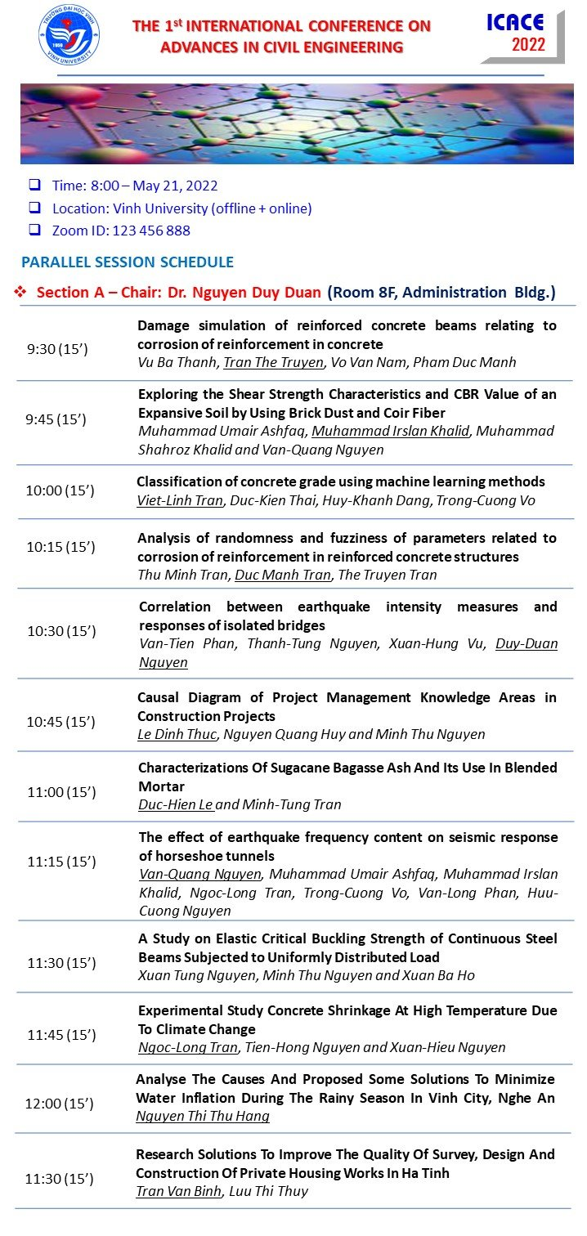

ANALYSE THE CAUSES AND PROPOSED SOME SOLUTIONS TO MINIMIZE WATER INFLATION DURING THE RAINY SEASON IN VINH CITY, NGHE AN
Nguyen Thi Thu Hang
Construction department, Vinh university
Email: thuhang@vinhuni.edu.vn

Flooding is a typical phenomenon in urban areas in Central Vietnam during the rainy season that lasts from June to October every year. Vinh city of Nghe An province is greatly affected by this phenomenon. In particular, in recent times, the rapid urbanization has caused rivers to be filled a lot, flood storage space is narrowed, the drainage system is overloaded causing widespread flooding in the rainy seasons, leading to economic activities such as fisheries, Industry, agriculture will emit a large source of wastewater containing many toxic chemicals. This article aims to analyse the causes and proposed some measures to overcome the prolonged flooding in the flood season in Vinh city of Nghe An province.
Keywords: Vinh city, Flooding, technical infrastructure, drainage, flooding.
- Introduce
In recent years, the appearance of the city has changed significantly. The city's economic structure start turning positively, economic growth is on rise, urban infrastructure is focused on investment, architecture, urban landscape is interested in renovating and building new. However, along with the fear of socio-economic development, the rapid pace of urbanization, the urban space is constantly expanding, which means that the rate of concreteization increases rapidly the area of ponds and lowlying areas decreases leading to the drainage completely dependent on new construction ditches. In addition, the drainage system has been around for a long time, many ditches are settled and degraded, while the construction of new, repaired and repaired is not synchronized, causing many drainage works to not be fully promoted effectively.
Urban flooding suffers great economic and even lifethreatening damage, so fighting urban flooding is a measure to help grow the economy. In order to effectively prevent flooding in Vinh city, it is necessary to have a synchronous solution, strategic planning and especially need the input of experts and community consciousness in flood prevention.
This article outlines the causes and solutions to limit flooding in the city with non-construction solutions and works combined harmoniously, supporting each other. In parallel with the construction measures such as: Expanding drainage canals, adding valve doors at the sewer site, building flood reservoirs and slowing floods, it is necessary to take non-construction measures such as: land management of flood zones, flood forecasting, restoration and flood insurance, share the losses caused by the flood.
- Natural characteristics - society of Vinh city affect the flood situation
  - Geographic location
Vinh City is a Class I municipality, the political and economic and cultural center of Nghe An province, located in the south of the province, downstream of the Nam - Hung - Nghi region, surrounded by 4 main rivers: Dao River, Cua Tien River in the South, Ke Gai River in the West, Rao Dung River in the Northeast, The Lam River in the east and south of the city. The city centre is 17km west of the East ocean, the nearest point about 3km from the East ocean.
  - Climate
Average annual rainfall from 1.800÷2.043mm (Nghi Loc: 1.800mm, Vinh: 2.043mm). Concentrated mainly on the rainy season, rainfall in 3 months 8, 9, 10 (accounting for 61% of the rainfall for the whole year). The largest 1 day rainfall reached 596,7mm (11th October 1989), the largest 3-days rainfall can reach 950 mm (14th÷16th October 2019), the heaviest 5-day rain can reach over 1.000mm (14th÷18th October 2010). The highest hourly rainfall was 142mm (8thOctober1965 in Vinh). Largest water level on Lam River: In Ben Thuy: 5,64 m; at Rao Dung: 3,15 m (28th September 1978)[2]
According to the climate change scenario of the Ministry of Natural Resources and Environment published in 2011: The average rainfall forecast will increase by 1,2% (in 2020) by 1,7% (in 2030) 3,1% (in 2050) 5,9% (in 2100). Sea level rise forecast: increase 7÷8 cm (2020) 11÷13cm (2030) 20÷24 cm (2050), 49÷65cm (2100)[3]
  - Social
In recent years, the speed of urbanization in Vinh has been rapid: the administrative boundaries have been opened further to the west, from 13 wards now increased to 16 wards, 5 communes increased to 9 communes, the natural area of the whole city increased from 67.53 km² to 104.96 km², of which the area of the central area reached nearly 36 km². By 2020, the area of the whole city is up to 250 km². Regarding the future, vinh city urban area includes: vinh urban area, Cua Lo town, Quan Hanh town and new urban areas according to the plan. Vinh was recognized as a class 1 municipality in decision No. 1210 dated 5th September 2008 of the Prime Minister.
  - Drainage system
According to the natural terrain, the main escape direction of the city is to the South and Southeast flowing into the main rivers such as the Lam River, Vinh River, Ke Gai River, and Dao Rung river. Vinh City's drainage system includes:
- Vinh – Ke Gai river system and Rao Dung river serve the drainage of the Lam River and The East Ocean.
- The main ditch system consists of North Canal, head canal, secondary canal, tertiary canal, Hong Bang Ditch and Dong Vinh Ditch with a total length of about 15km. The main ditch system drains the water itself or pumps forcibly into the river when the flood rise.
- Secondary and tertiary canal system of the basin with a total length of about 400km;
The system operates according to the principle: Rainwater of each basin is collected to the system of ditches, secondary and tertiary sewers and flow to the system of head ditches, then flow to the Ke Gai River in the west, Vinh river in the south and Rao Dung river in the east flowing to the Lam River. The city is divided into 4 main drainage basins.
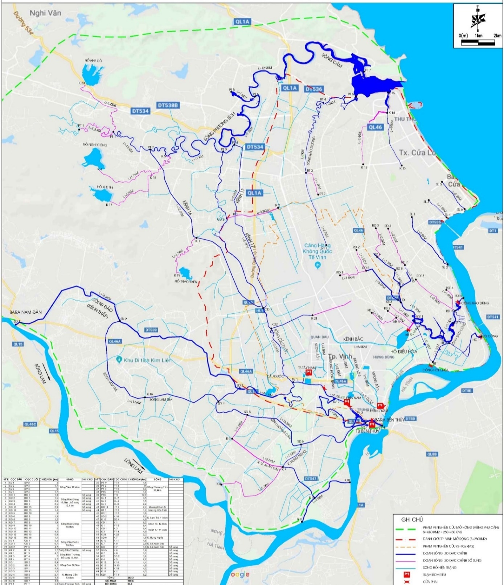
Figure 1: Map of vinh city river basin (source of Nghe An irrigation department)

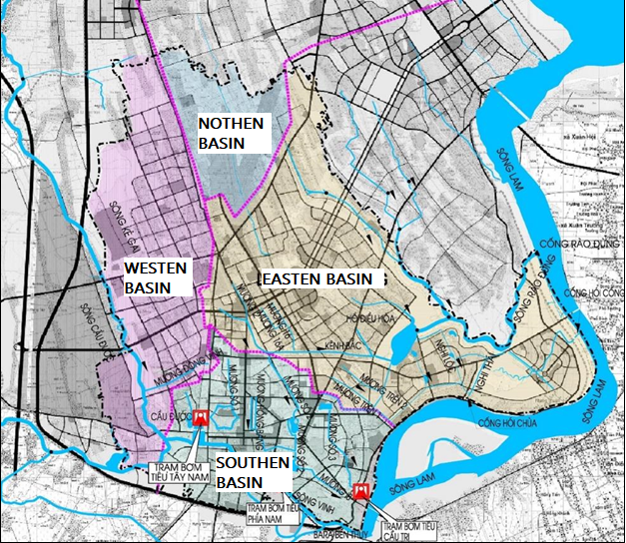
Figure 2: Drainage basins of the city (source: Nghe An Irrigation Department)

  - Current status of drainage works system
- Sedimentation and congestion on the ditch routes are common. The main reason is that the funding allocated to maintain, dredge, connect the drainage system is located too little compared to the scale of the system. People's awareness in protecting the drainage system is not high, the situation of dumping waste into drainage ditches causes local congestion at many points on the system while it is difficult to check for treatment.
- Some focal works (pump, water saving installation, full tide coferdam) no longer meet the real needs. The reason is that the application of calculation parameters at the time of planning in 2004 is no longer suitable for the current period due to the negative impact of climate change (unseasonal rain, heavy rainfall, rising sea and river levels). According to calculations for rainfall exceeding 120mm/hour, the works in the city's drainage system will not meet. However, the reality is that the system only works about 70% of the capacity (equivalent to about 84mm/hour of rainfall)

Table 1: Summary of drainage ditches of Vinh City
N. | Ditch | Start point | End point | Size | Fabric | Length
1 | Main canal | Phan Boi Chau | Hao Thanh, Tay Nam pumping station | -Drain ditch 4,0x1,5m  -Closed ditch 4,0x1,5m  - Drain ditch 5,0x1,8m | -Placed rockfill  -Armoured Concrete  -Placed rockfill | -795m  -860m  -1300m
2 | Secondary canal | Nguyen Sy Sach | Vinh Tan lake | -2,0x1,4m  -5,0x1,8m | -Armoured Concrete | 2300m
3 | Tertiary canal | Goong lake | Air conditioner No. 3 | -Drain ditch 4,0x1,6m  -Closed ditch,5x2,0m | -Placed rockfill  -Armoured Concrete | -1600m  -450m
4 | No. 4 ditch | Truong Chinh | Ke Gai river | -Drain ditch 4,0x1,6m  -Closed ditch 5,5x2,0m | -Placed rockfill  -Armoured Concrete | -1250m  -800m
5 | Hong Bang ditch | - Apartment C8  -Tran Phu | -Tran Phu  -Vinh Tân lake | -1m -:- 1,5m  -4,5m | -Coarse rock  -Armoured Concrete | -1270m  -956m
6 | North channel | - Mai Hac De  -Ha Huy Tap  -Nguyen Phong Sac | - Equalizing basin 1  -Nguyen Phong Sac  - Balancing tank | -Closed ditch 3,0x2,5m  -11x23m  -17,55m | -Armoured Concrete | 6800m

Table 2: Assessment of the situation of flooding of Vinh city in recent years
Year | Flooded area, flooded route | Flooding depth | Damages
2016 | Quang Trung, Phan Boi Chau, Ly Thuong Kiet, Dinh Cong Trang, Hong Bang, Nguyen Thai Hoc, Nguyen Van Cu, Le Hong Phong, Nguyen Thi Minh Khai, Le Loi, Le Nin, Mai Hac De | 0,5m-1,0m
2017 | - Yen Giang area, Vinh Tan, Cua Tien, Ben Thuy  -Dinh Cong Trang, Hong Bang, Dan Thai Than, Quang Trung  -Vinh Market | >1,0m  0,5m-1,0m  1,5m
2018 | -Nguyen Van Cu, Dang Thai Than, Quang Trung, Nguyen Thi Minh Khai, Dinh Cong Trang, Le Hong Phong, Ly Thuong Kiet, Le Nin  -Truong Thi | 0,5m-0,7m  0,4m
2019 | - Nguyen Thi Minh Khai, Dang Thai Than, Phan Boi Chau, Dinh Cong Trang, Le Ninh, Phong Dinh Cang, Quang Trung, Ly Thuong Kiet, Le Hong Phong, Le Nin, Nguyen Van Cu  - Vinh Market | 0,5m-1,0m  1,2m | -Evacuate 250 households  -20,000 birds died  -370ha of ponds and lakes for farming  -54ha of rice, 195ha of vegetables
2020 | -Trung Do, Ben Thuy  - Vinh Market | 0,8m-1,5m  1,5m

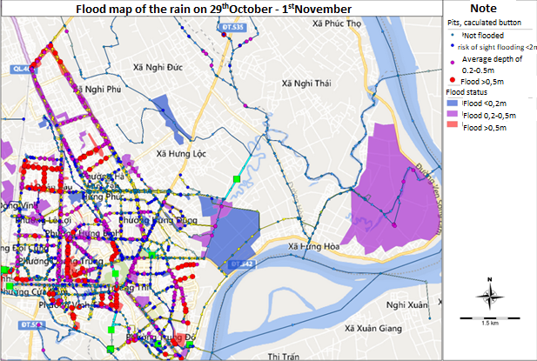
Figure 3: Flood map of Vinh city in 2020 (source: Nghe An Irrigation Department)

  - General assessment of the cause of flooding in Vinh City
- Rapid urbanization: The settlement with a high population density leads to the rapid concrete of the urban surface, which makes the area of water permeability less, preventing the possibility of on-site drainage in the event of heavy rain.
- The technical infrastructure is not synchronized, incomplete, the size of the sewer is too small, the quality of materials is low.
- Inadequate operation and maintenance, lack of cooperation from the community leading to reduced capacity of flow, clogged pipes and manholes due to indiscriminate waste
- In recent years, unusual climatic conditions have caused extreme rainfall events of intensity, frequency and morphology, along with sea level rise leading to high flood risks for Vinh city. Heavy rain lasted for many days, and the rain drainage system was not guaranteed, again encountered when the water level on the Lam River was high, leading to drainage for vinh city area very slowly causing flooding in the urban and surrounding areas.
3. Flood protection solution for Vinh city
3.1. Rainwater storage solution
3.1.1. Solutions for planning and development of Equalizing basin system
Vinh city has 22 lakes with a total area of about 400ha scattered in the city. Lakes play a very important role in storing buffer water to drain water for residential areas.

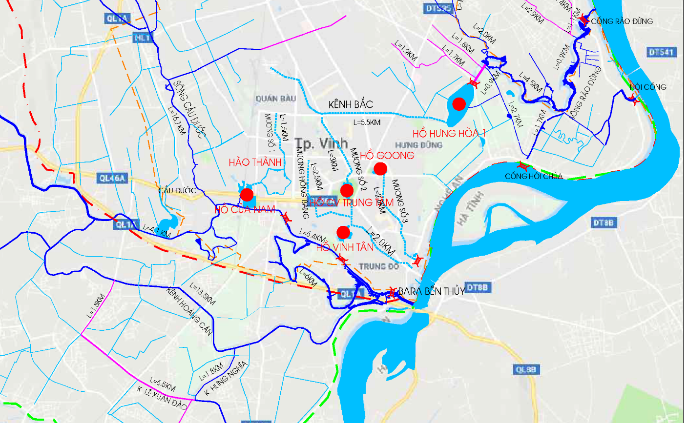
Figure 4: Large lakes and drain locations in the city
(source of Vinh Urban Infrastructure Management and Development Joint Stock Company)
However, urban development along with the increase in population leads to the exploitation of unplanned premises, occupied open surfaces, obstructed flow. Meanwhile, the drainage system is built in a patchwork style, exists in the planning of design, construction, management, so every rainy season, many parts of the city are flooded. Taking advantage of the water storage capacity of the air-conditioned lakes to minimize flooding for Vinh city in the current urbanization context is very necessary.
Criteria for selection of air-conditioned lake location
- There is a suitable terrain height for rainwater to flow to the lake with the greatest flow.
- The flow obtained from the sewer routes level 2, the canal flowing to the lake has the shortest time.
- The flow in and out of the lake is the most reasonable.
- Less relocation, in accordance with the land use planning.
- Combine the surrounding works to improve nature, create an ecological landscape.
With a rain intensity of 576mm, the flow required for a period of 180 minutes is about 113 million m³. Meanwhile, the maximum storage capacity of air-conditioned lakes is about 39 million m³. Therefore, it is necessary to combine with the solution of operating reasonable water regulation works to lower the water level in the canals and canals to wait for the amount of water to be drained.
    - Improved surface permeability
In the past, thanks to the empty land area, when it rained down, most of the water was soaked into the ground so there was no flooding. But today, with the rapid urban development has greatly reduced the permeable area, greatly affecting the ability to drain naturally. So to increase the water permeability of the surface, recommend the following measures:
- Minimize unnecessary concrete area
- Increase the area of trees and lawns in the garden of houses and offices and enterprises
- For pedestrian walkways, replace concrete materials or sealed tiles with tile or gravel to increase absorbency[4]
- For road surface, replace concrete or resin concrete materials with pervious concrete.
Increasing inverted capacity not only reduces the amount of water flowing on the road, but can also help increase the amount of precipitation seeping into the ground, adding water to groundwater sources. It is possible to apply pervious concrete structures with roads that are in need of upgrading in Vinh city.
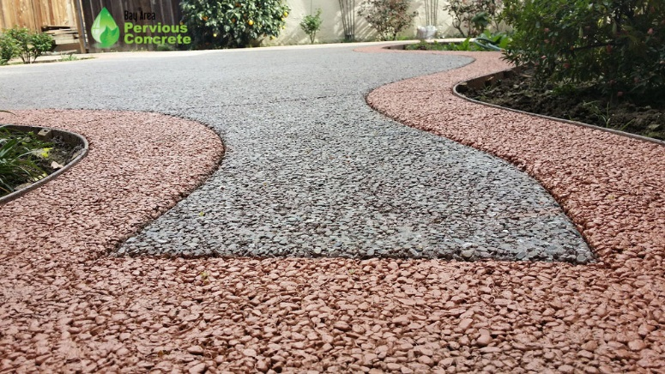
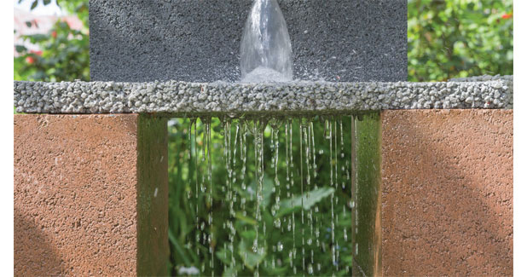

Figure 5: Pervious concrete (source: Internet)
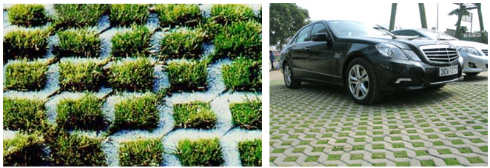
Figure 6: Reticulated molding of Car park tile (Source: Internet)
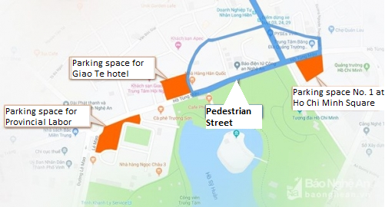
Vinh city is building 4 pedestrian streets including: Ho Tung Mau Street; Nguyen Van Cu Street; Nguyen Trung Ngan Street connects to Lane 2, Nguyen Trung Ngan Street, the end point intersects Nguyen Van Cu Street and Nguyen Tai Street. Expected parking space for cars includes: Parking space No. 1 at Ho Chi Minh Square, Parking space for Giao Te Hotel and Provincial Labor Culture department. Reticulated molding can be applied in these parking lots.
Figure 7: Expected parking space on pedestrian street (source nguyen24h.vn)

    - Water flood by reservoir
Rainwater reservoir solutions have been applied over the years and are still being used in cities around the world today. Rainwater is stored on the roof or channeled into ground water tanks. It is possible to use regulations or encourage people to use this method.
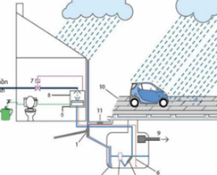
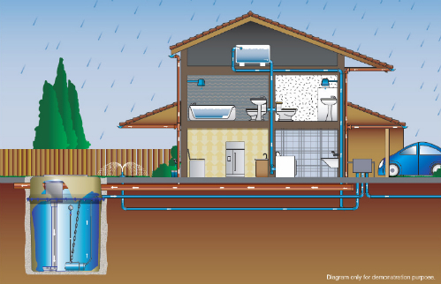
Figure 8: Typical rainwater collection system of houses (Source Internet)
Build underground water tanks with tanks higher than the road surface to store rainwater. Flood computation Calculate the tank capacity and the reasonable amount to accommodate the above amount of water. Use large capacity pumping stations to pump the amount of flooded water into the tank. Using this water for watering plants, washing roads, fighting fires will not be wasted water resources. Locations can be built: bus station, green park, stadium, amusement park, square, school campus.
Figure 9: Rainwater storage under the parks

  - Methods of Improvement
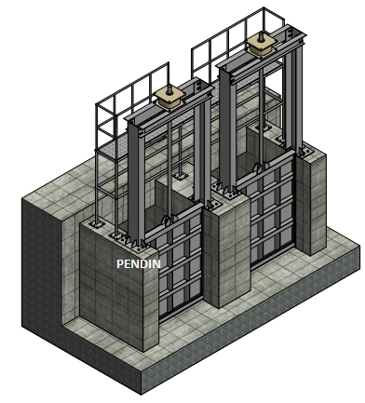
Reduce the level of flooding by adding a relief damper structure and in combination with a portable pumping station. When the rain is heavy, the water level in the urban area will be lower than the water level in the canal or river, the valve door will close. The pumping station operates to draw water from the water collection pit to the river or canal while increasing the speed at which the water flows to the drain until the internal water pressure is greater than outside the river, then the valve door will open to drain the water to the river. If localized flooding occurs due to the flow velocity in the small drain, we can use the pump at the outlet to increase the flow velocity in the drain, then the level of flooding and the time of flooding in the area will be reduced and shortened.

Figure 10: Arrange the valve door at the drain site

Proposing the list of works in the order of priority of construction in phases based on the current status quo, the general planning of Vinh city and the zoning plan of approved communes is also an effective method of improvement.
Table 3: Expected immediate investment in projects that need improvement
N | Project | Technical solutions | Investment objectives
1 | Expand the water collector and increase the capacity of the Black Bridge pumping station | Construction and expansion of the water collector of the Black Bridge pumping station as planned; increase the total pumping station capacity from 54,000m³/h to 71,000m³/h | Addressing flooding in Hung Binh, Hung Phu, Truong Thi, Trung Do and Vinh Tan wards
2 | Raising the capacity of The Tri Bridge Pumping Station (Ben Thuy) | Increase the total pumping station capacity from 20,000m³/h to 40,000m³/h | Flood settlement for Truong Thi wards, Ben Thuy
3 | Construction of pepper pumping station in Vinh market area | Investment in building a reservoir Vinh market water and building a pumping station with a capacity of 25,000 m³/h | Flood settlement for Le Mao, Quang Trung and Hong Son
4 | Construction of Can Linh Pagoda pumping station to replace Tay Nam pumping station | Construction of new pumping station at Can Linh Pagoda with capacity of 30,000 m³/h | Flood settlement for Cua Nam, Đoi Cung, Hung Chinh
5 | Construction of Cua Tien bridge pumping station (Phạm Hồng Thái) | Construction of Cua Tien bridge pumping station for water consumption and water supply with a capacity of 5000 m³/h | Flood settlement for Quang Trung and Cua Nam
6 | Construction of Bald Pagoda pumping station | Construction of new pumping station  capacity of 130,000m³/h, in Hung Hoa | Flood settlement for North channel, Hưng Dung, Hung Loc, Hung Hoa wards.
7 | Construction of Hung Hoa equalizing basin 2 | New construction of Hung Hoa equalizing basin 2, water surface area from 40-45ha | Flood settlement for Norh channel, Hung Dung, Hung Loc, Hung Hoa wards
8 | Renovation of Vinh river | Dredging and renovating embankments on both sides of the Vinh River | Renovating the landscape, solving flooding in Vinh Tan ward
9 | Channel system connecting Hung Hoa 1 equalizing basin and Hung Hoa 2 equalizing basin | New construction of canal system connecting 2 equalizing basin and bald pumping station | Flood settlement for North channel, Hung Dung, Hung Loc, Hung Hoa wards.

Table 4: Expected long-term improvement of facilities
N | Project | Technical solutions | Investment objectives
1 | Channel 80m section from The Thorny River to The Barrier River | New construction of 80m canal according to general planning and zoning plan of Vinh city | Building the main channel for Bac Vinh area, renovating the landscape and solving flooding for Hung Dong commune, Quan Bau ward, Ha Huy Tap and Nghi Phu commune, Nghi Duc completed the main target system of the city
2 | Construction of Nghi Duc air-conditioned lake | New construction of air-conditioned lakes according to the general planning and zoning planning of Vinh City | Renovating the landscape, establishing buffer water consumption zones for Nghi Duc and Nghi Phu communes
3 | Construction of canal from Nghi Duc Air-conditioned Lake to Hung Hoa 1 Air Conditioning Lake | New construction of canal according to general planning and zoning plan of Vinh city | To build the main drainage canal for the North Vinh area, improve the landscape and deal with flooding for the area of ​​Hung Dong commune, Quan Bau ward, Ha Huy Tap and Nghi Phu commune, Nghi Duc to complete the city's main drainage system.
4 | Construction of canal and air-condition Nghi Kim – Nghi Liên – Kẻ Gai | New construction of canal and air-condition according to general planning and zoning plan of Vinh city | Shaping the main drainage system for the Northwest region to serve urban development and complete the City's technical infrastructure
5 | Dredging, renovating and embankment of Ke Gai river, section through Vinh city | Rehabilitation of rivers and works on the route according to general planning and zoning plan of Vinh city | Landscape improvement, urban space expansion, drainage for the area of ​​Cua Nam, Dong Vinh, Hung Chinh, Nghi Kim, Nghi Lien wards

References
[1] Resolution No. 26-NQ/TW dated 30th July 2013 of the Politburo
[2] Statistics on climate situation in Nghe An of Nghe An irrigation department
[3] Japan International Cooperation Agency JICA (1999). Research on municipal drainage and wastewater treatment systems
[4] Tran Hieu Nhue, Tran Đuc Ha, Đo Hai, Ung Quoc Dung, Nguyen Van Tin (1996) Water supply and drainage, Hanoi Science and Technology Publishing House
[5] Prof. Dr Le Sam and associates (2014) Flood protection solutions for big cities, Agriculture publishing house
[6] Documents and images of flooding, urban drainage of experts and scientists are posted on the Internet

